|  |  |
| --- | --- |
| Sutton Physical Activity Grant MicroGrant 2022-23Application Form **Funded by Sutton Council and administered by Community Action Sutton** |  |

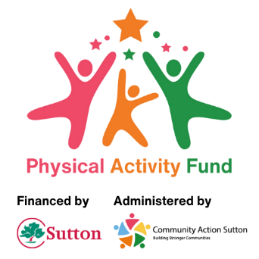

**Please read the guidance before you start filling this form in**. You might also find it helpful to contact Razia Sattar from Community Action Sutton before completing your application by emailing Razia@communityactionsutton.org.uk.

Please do not attach any additional information that is not explicitly requested in the application form.

Email completed applications with scanned copies of supporting documents to: [**enquiries@communityactionsutton.org.uk**](mailto:enquiries@communityactionsutton.org.uk) we will **not accept paper applications** unless there are exceptional circumstances.

If you would like help completing your application form contact Razia Sattar at Community Action Sutton on [Razia@communityactionsutton.org.uk](mailto:Razia@communityactionsutton.org.uk).

|  |  |
| --- | --- |
| Part One: Contact information | |
| **Please complete for the main contact for your group. This person must be a member of your organisation.** | |
| 1. Name of Voluntary and Community Group |  |
| 1. Address of Voluntary and Community Group |  |
| 1. Title |  |
| 1. Forenames (in full) |  |
| 1. Surname |  |
| 1. Position in organisation |  |
| 1. Address |  |
| 1. Phone number |  |
| 1. Email address |  |
| 1. Do you have any communication needs? | Yes/No |
| If yes, what are your communication needs? |  |
| 1. Please give details of the bank or building society account into which we would pay the grant:  * Name of the bank or building society you hold an account with * Your account name (the organisation name on your statements) * Sort code * Account number |  |

|  |  |
| --- | --- |
| **Part Two: Your Proposal** | |
| Please give a brief description of your proposal which sets out what you intend to use the microgrant for (Max 250 words). | |
|  | |
| 1. Total cost of your proposed project | £ |

|  |  |
| --- | --- |
| **Part Three: Please check that you have included copies of the following supporting documentation** | |
| Copy of most recent bank statement |  |

I agree that the information provided on this form is true and correct and I agree that if my application is successful, the money can be paid into the account details stated above.

|  |  |
| --- | --- |
| Name |  |
| Position in organisation |  |
| Date |  |

**Please send your completed application form with a scanned copy of relevant documents to:** [**enquiries@communityactionsutton.org.uk**](mailto:enquiries@communityactionsutton.org.uk)